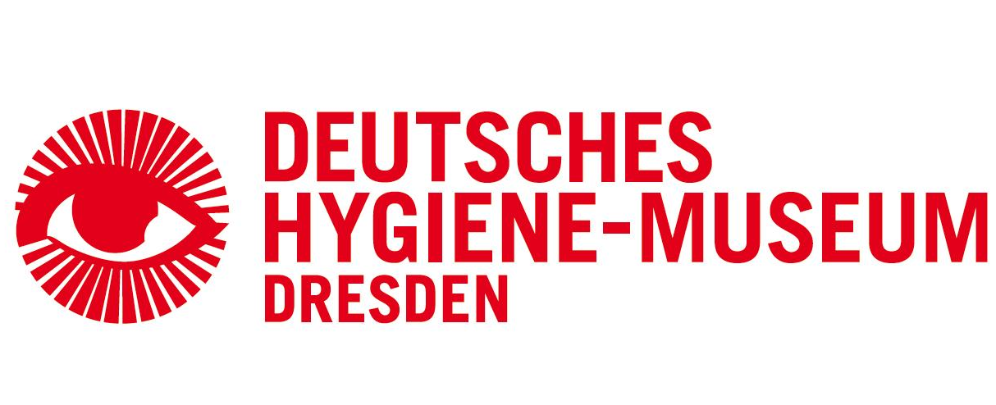
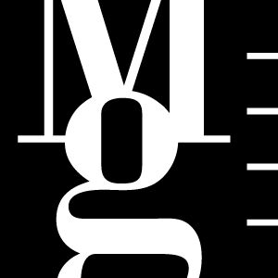

Images of the Mind
In Art and Science


Unique exhibition project of the Moravian Gallery in Brno and The Deutsches Hygiene-Museum in Dresden

Moravian Gallery in Brno
Museum of Applied Arts, Husova 14, Brno
9th December 2011 — 18th March 2012
opening 8th December 2011 at 17.00

Deutsches Hygiene-Museum Dresden / DHMD
Lingnerplatz 1, Dresden
22 nd July – 31st October 2011

www.dhmd.de

EXHIBTION AUTHORS
Ladislav Kesner
Colleen M. Schmitz

MG EXHIBITION CURATOR
Petr Tomášek

The Moravian Gallery in Brno has prepared, in collaboration with the Deutsches Hygiene-Museum in Dresden, a truly outstanding international exhibition Images of the Mind which will enable visitors to see for the very first time in the Czech Republic original drawings by Leonardo da Vinci.
The premiere of this exhibition project has taken place between 23nd July and 31st October in Dresden. It will then be transferred to the Museum of Applied Arts of the Moravian Gallery in Brno where it will be on show from 9th December 2011 to 18th March 2012.
The exhibition entitled Images of the Mind brings together artistic and scientific illustrations and imaging and presents the human mind as a visual theme. The visitors will be given the rare opportunity of receiving an insight into this difficult to capture phenomenon. In addition to the aesthetic experience it will provide many new facts. The valuable exhibits on show will range from medicine tractates and illuminated manuscripts, to medicinal illustrations from the 19th century, to the works of modern and contemporary art, including installations, new media and video, to high-tech biomedicine images and visualisations. The exhibition will further embrace a broad spectrum of artistic expression of various provenance which depicts the working of the mind — such as Renaissance portraits representing the “movement of the mind” and examples of Chinese landscape painting created as clear metaphors of the human mind, works of art of classic modernism and contemporary art, including installations, new media and video art. A specific aim of the project is to highlight the possibilities and hazards of the new images of the mind and question the traditional divide between scientific and artistic images and the values that we assign to them and associate with them.

“This unique project, initiated by art historian Ladislav Kesner, aims to comprehensively present the human mind as represented by different types of historical and contemporary works of art and scientific illustrations and aids. Being an institution with complete coverage the Moravian Gallery in Brno intends to use this exhibition as a vehicle to spark off broad dialogue between science, society and culture.
Thanks to four years of preparation work and serious effort on the part of the team in the Moravian Gallery in Brno as well as intensive collaboration with our partner from abroad visitors to the Moravian Gallery in Brno will be given an opportunity to see important works from over sixty museums and galleries world-wide including original drawings by Leonardo da Vinci on show for the first time in the Czech Republic.
The exhibition and the accompanying publication will, at the same time, provide a view of the history and circumstances of “reading the mind from pictures” and explain how philosophers, art historians, psychiatrists and radiologists interpret their images of the human mind and what concepts of the mind evolve from such interpretations.”
Marek Pokorný
director Moravian Gallery in Brno

”Over the past few decades neurosciences and cognitive sciences have made a giant leap in understanding the human mind. Using new imaging technologies capable of visualising both physical structures and the processes and changes in the brain in real time, scientists are seeking answers to essential questions on the nature of the human mind and the processes through which the human brain as a biological entity produces the mind. However, the mind is not just a scientific phenomenon but also a cultural one with a long tradition in the humanities and art and plays an important part there. Modern scientific and diagnostic images of the brain can thus be perceived in the context of other types of pictures which have captured the most varied forms and expressions of the human mind for centuries employing their specific means — together with artistic pictures. Fine art from various periods and origins has been for centuries also perceived as an expression, symptom, or simply an image: of emotions, perception, imagination, memory and other conscious and non-conscious capacities of the human mind. Many artists (mostly but not exclusively from the period of modernism) consciously and purposefully created their works as metaphors of the human mind. The present dynamic development of neuroscience and cognitive sciences generates the need and opportunity for new forms of multidisciplinary collaboration and dialogue between the biomedicinal domain and the humanities, as well as science and art.“
Ladislav Kesner
exhibition concept author

“On 22nd July 2011 we opened the exhibition "Images of the Mind in Art and Science" at the Deutsches Hygiene-Museum in Dresden and since then we have had almost 20,000 visitors. This is really pleasing and shows the great interest in this complex and rather difficult subject. The feedback from our visitors has been extremely positive. Not only the content of the exhibition has been the subject of praise, but also the design seems to provide a good atmosphere in which to spend time viewing the different sections. The press reviews have also been favourable, commenting that the exhibition succeeds in making the intangible comprehensible in picturing the mind. The link between art and science has been found to be very interesting due to its capacity to open up new perspectives to the viewer. Also the detailed descriptions of the objects, many of which are rare and original, are considered to have made the complexity of the content broadly accessible. On the basis of the local, national and international response we feel confident in evaluating this cooperation as a success.”
Klaus Vogel, director DHMD

SELECTION FROM THE ARTISTS ON SHOW
foreign artists: Leonardo da Vinci, Albrecht Dürer, Lucas Cranach Sr., Rembrandt van Rijn, Jacopo Bassano, Giovanni Battista Tiepolo, Caspar David Friedrich, Max Klinger, Edvard Munch, Oskar Kokoschka, Ernst Barlach, Martin Kippenberger and others
Czech artists: Josef Šíma, Bohumil Kubišta, Jindřich Štyrský, Toyen, Josef Váchal, Jan Zrzavý, Karel Malich, Adriena Šimotová, Jiří Černický and others

LOANS FROM MUSEUMS WORLD-WIDE
British Royal Collections in Windsor, École nationale supérieure des beaux-arts in Paris, Museum Boijmans Van Beuningen in Rotterdam, Städel Museum in Frankfurt, International Center of Photography in New York, Instituto Cajal in Madrid, Albertina and Belvedere in Vienna and many others; from the Czech Republic National Gallery in Prague, City Gallery Prague, West Bohemian Gallery in Pilsen, Moravian Library, National Medical Library and others.

The Deutsches Hygiene-Museum IN DRESDEN

An institution that focuses on the cultural, social and scientific changes in society at the beginning of the 21st century. From its inception in 1912 this Dresden museum has been acclaimed as one of the most original cultural and scientific establishments in the world. Its exhibitions deal with themes from culture, society, science and art. The permanent exhibition collectively covers themes dedicated to the body and health. Attractive architecture, installations using modern media and interactive elements as well as traditional exhibits combine to create an exceptional experience. The slogan of the permanent exhibition “Marveling – Learning – Trying out” is also fitting for the Children’s Museum which in a playful manner attempts to explain the five human senses.

The exhibition is held under the auspices of the prime mister of the government of the Czech Republic Petr Nečas and the prime mister of the government of the Free State of Saxony Stanislaw Tillich.
MAIN PARTNER /MEDIA PARTNERS



CONTACT FOR MEDIA
Martina Vašková, marketing and communication department, +420 724 516 672, +420 532 169 174
tisk@moravska-galerie.cz

